Name:\_\_\_\_\_\_\_\_\_\_\_\_\_\_\_\_\_

**What’s the Dam Problem?**

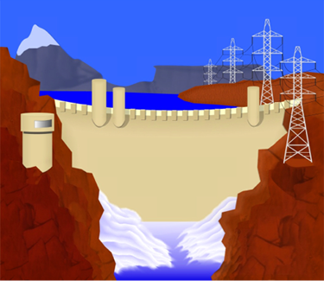**Background**

With the exception of the Great Wall of China, dams are the largest structures ever built. Throughout history, big dams have prevented flooding, irrigated farmland, and generated tremendous amounts of electricity. Without dams, modern life as we know it would simply not be the same.

**Hydropower Basics**

**Hydropower generates electricity**

Hydropower is the renewable energy source that produces the most electricity in the United States. It accounted for about 7% of total U.S. electricity generation and 56% of generation from all renewables in 2012.

**Hydropower relies on the water cycle**

Understanding the water cycle is important to understanding hydropower. In the water cycle:

* Solar energy heats water on the surface, causing it to evaporate.
* This water vapor condenses into clouds and falls back onto the surface as precipitation (rain, snow, etc.).
* The water flows through rivers back into the oceans, where it can evaporate and begin the cycle over again.

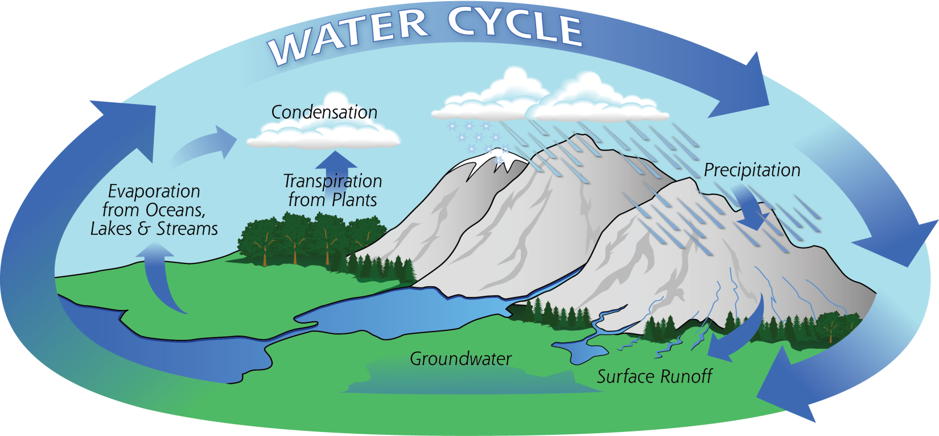

**Mechanical energy is harnessed from moving water**

The amount of available energy in moving water is determined by its flow or fall. Swiftly flowing water in a big river, like the Columbia River that forms the border between Oregon and Washington, carries a great deal of energy in its flow. Water descending rapidly from a very high point, like Niagara Falls in New York, also has lots of energy in its flow.

In either instance, the water flows through a pipe, or *penstock*, then pushes against and turns blades in a turbine to spin a generator to produce electricity. In a run-of-the-river system, the force of the current applies the needed pressure, while in a storage system, water is accumulated in reservoirs created by dams, then released as needed to generate electricity.

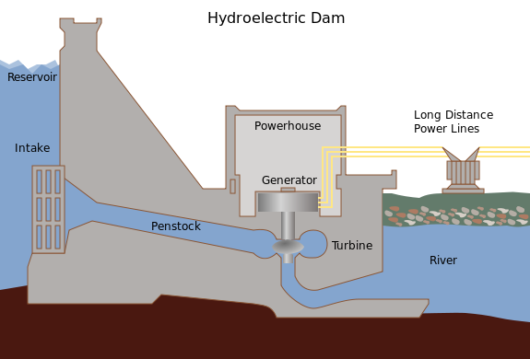

**History of hydropower**

Hydropower is one of the oldest sources of energy. It was used thousands of years ago to turn a paddle wheel for purposes such as grinding grain.  Our Nation's first industrial use of hydropower to generate electricity occurred in 1880, when 16 brush-arc lamps were powered using a water turbine at the Wolverine Chair Factory in Grand Rapids, Michigan.

The first U.S. hydroelectric power plant opened on the Fox River near Appleton, Wisconsin, on September 30, 1882.

Because the source of hydroelectric power is water, hydroelectric power plants must be located on a water source. Therefore, it wasn't until the technology to transmit electricity over long distances was developed that hydropower became widely used.

**Location of Hydropower**

Most U.S. hydropower is in the West. Over half of U.S. hydroelectric capacity for electricity generation is concentrated in three states: Washington, Oregon, and California. Approximately 29% of the total U.S. hydropower was generated in Washington in 2011, the location of the Nation's largest hydroelectric facility — the Grand Coulee Dam.

Most hydropower is produced at large facilities built by the federal government, such as the Grand Coulee Dam. The West has most of the largest dams, but there are numerous smaller facilities operating around the country.

Most dams were not built for power. Only a small percentage of all dams in the United States produce electricity. Most dams were constructed solely to provide irrigation and flood control.

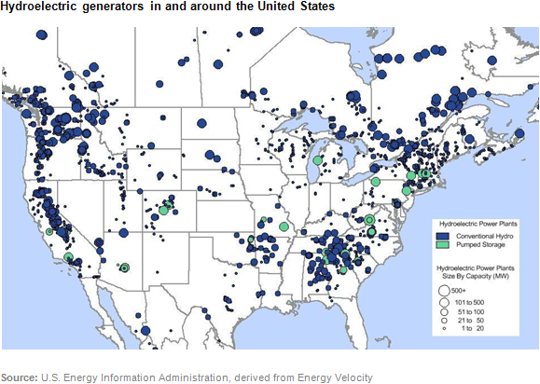

**Types of Dams**

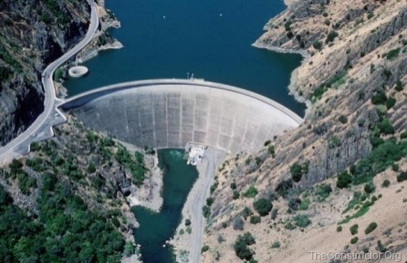Since the first large-scale dam was built in Egypt more than 5,000 years ago, engineers have devised various types of dams to withstand the forces of a raging river.

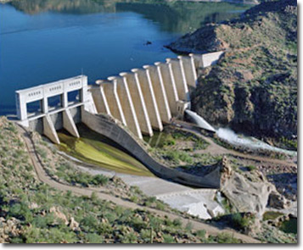**Arch dams** are good for narrow, rocky locations. They are curved, and the natural shape of the arch holds back the water in the reservoir. Arch dams, like the El Atazar Dam in Spain, are thin and require less material than any other type of dam

**Buttress dams** may be flat or curved, but one thing is certain: a series of supports, or [buttresses](http://www.pbs.org/wgbh/buildingbig/glossary.html#buttress), [brace](http://www.pbs.org/wgbh/buildingbig/glossary.html#brace) the dam on the downstream side. Most buttress dams, like the Bartlett Dam in Arizona, are made of [reinforced concrete](http://www.pbs.org/wgbh/buildingbig/glossary.html#reincon).

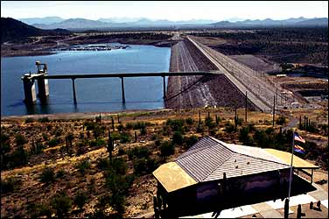

**_Embankment dams** are the most commonly built dams in the United States. They are massive dams made of earth and rock. Like gravity dams, embankment dams rely on their heavy weight to resist the [force](http://www.pbs.org/wgbh/buildingbig/glossary.html#force) of the water. But embankment dams are also armed with a dense, waterproof core that prevents water from seeping through the structure. Tailings dams -- large structures that hold back mining waste -- are a type of embankment dam.

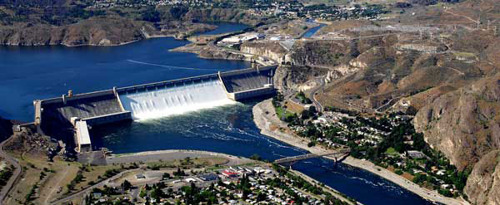

**Gravity dams** are massive dams that resist the thrust of water entirely by their own weight. Most gravity dams, like the [Grand Coulee Dam](http://www.pbs.org/wgbh/buildingbig/wonder/structure/grand_coulee.html) in Washington, are expensive to build because they require so much [concrete](http://www.pbs.org/wgbh/buildingbig/glossary.html#concrete). Still, many people prefer its solid appearance to the thinner arch and buttress dams.

All dams -- whether they're embankment, buttress, arch, or gravity -- must be maintained as they get older. Without proper maintenance, [spillways](http://www.pbs.org/wgbh/buildingbig/glossary.html#spillway) can clog and concrete can crack. Some dams are even removed because they block the migration of fish.

When should dams be taken down? When should they be repaired? Engineers must consider the services that each dam provides and the environmental impact that each dam creates before they make this decision -- and this isn't easy. Oftentimes, there is no right answer.

**Hydropower & the Environment**

Hydropower generators produce clean (no fossil fuels burned) electricity, but hydropower does have environmental impacts. Most dams in the United States were built mainly for flood control and supply of water for cities and irrigation. A small number of dams were built specifically for hydropower generation. While hydropower (hydro-electric) generators do not directly produce emissions of air pollutants, hydropower dams, reservoirs, and the operation of generators can have environmental impacts.

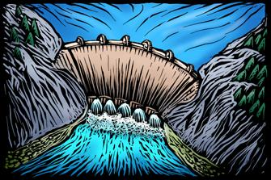A dam to create a reservoir may obstruct migration of fish to their upstream spawning areas. A reservoir and operation of the dam can also change the natural water temperatures, chemistry, flow characteristics, and silt loads, all of which can lead to significant changes in the ecology (living organisms and the environment) and rocks and land forms of the river upstream and downstream. These changes may have negative impacts on native plants and animals in and next to the river, and in the deltas that form where rivers empty into the ocean. Reservoirs may cover important natural areas, agricultural land, and archeological sites, and cause the relocation of people.

Greenhouse gases, carbon dioxide and methane, may also form in reservoirs and be emitted to the atmosphere. The exact amount of greenhouse gases produced from hydropower plant reservoirs is uncertain.  The emissions from reservoirs in tropical and temperate regions, including the United States, may be equal to or greater than the greenhouse effect of the carbon dioxide emissions from an equivalent amount of electricity generated with fossil fuels.

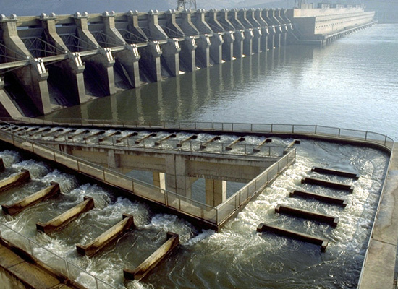Fish ladders help salmon reach their spawning grounds. Hydro turbines kill and injure some of the fish that pass through the turbine. The U.S. Department of Energy has sponsored research and development of turbines that could reduce fish deaths to less than 2%, in comparison to fish kills of 5 to 10% for the best existing turbines.

In the Columbia River, along the border of Oregon and Washington, salmon must swim upstream to their spawning grounds to reproduce, but the series of dams along the river gets in their way. Different approaches to fixing this problem have been used, including the construction of "fish ladders" that help the salmon "step up" and around the dam to the spawning grounds upstream.

**So the question remains:**

**To Dam or Not to Dam?**